**Karan Arora** **R.L. Institute M: 9416974837**

**Max Time : 2 hr** **Class : 12th Chemistry Max Marks : 50**

**Electrochemistry + Biomolecules + D & F- Block**

1. Multiple choice Questions: [ 1 x 15 = 15 ]
2. Which one of the following is not a good conductor of electricity?

|  |  |  |  |
| --- | --- | --- | --- |
| a) CH3COONa | b) C2H5OH | c) NaCl | d) KOH |

1. When aqueous solution of NaCl is electrolysed:

|  |  |  |  |
| --- | --- | --- | --- |
| a) Cl2 is evolved at cathode | b) H2 is evolved at cathode | c) Na is deposited at cathode | d) Na appears at anode |

1. $Λ_{m ({NH}_{4}OH)}^{ο}$ is equal to :

|  |  |
| --- | --- |
| a) $Λ_{m ({NH}_{4}OH)}^{ο}$ + $Λ_{m ({NH}_{4}Cl)}^{ο}$– $Λ_{m (HCl)}^{ο}$ | b) $Λ_{m ({NH}_{4}Cl)}^{ο}$ + $Λ_{m (NaOH)}^{ο}$– $Λ_{m (NaCl)}^{ο}$ |
| c) $Λ_{m ({NH}_{4}Cl)}^{ο}$ + $Λ_{m \left(NaCl\right)}^{ο}$– $Λ_{m (NaOH)}^{ο}$ | d) $Λ_{m (NaOH)}^{ο}$ + $Λ_{m (NaCl)}^{ο}$– $Λ_{m ({NH}_{4}Cl)}^{ο}$ |

1. The limiting molar conductivities o for NaCl , KBr and KCl are 126 , 152 and 150 S cm2 mol – 1 respectively. The o for NaBr is :

|  |  |  |  |
| --- | --- | --- | --- |
| a) 278 S cm2 mol – 1 | b) 176 S cm2 mol – 1 | c) 128 S cm2 mol – 1 | d) 302 S cm2 mol – 1 |

1. The sequence of ionic mobility in the aqueous solution is :

|  |  |  |  |
| --- | --- | --- | --- |
| a) K + > Na + > Rb + > Cs + | b) Cs + > Rb + > K + > Na + | c) Rb + > K + > Cs + > Na + | d) Na + > K + > Rb + > Cs + |

1. + I2 + Cr 3+ , = 0.79 V ; = 1.33 V ; $E_{I_{2}}^{o}$ = ?

|  |  |  |  |
| --- | --- | --- | --- |
| a) 0.54 V | b) – 0.054 V | c) + 0.18 V | d) – 0.18 V |

1. In the lead-acid battery during charging , the cathode reaction is :

|  |  |
| --- | --- |
| a) Formation of PbO2 | b) Formation of PbSO4 |
| c) Reduction of Pb 2+ to Pb | d) Decomposition of Pb at the anode |

1. Which of the following oxidation state is common for all lanthanoids?

|  |  |  |  |
| --- | --- | --- | --- |
| a) + 2 | b) + 3 | c) + 4 | d) + 5 |

1. On addition of small amount of KMnO4 to concentrated H2SO4, a green oily compound is obtained which is highly explosive in nature. Identify the compound from the following :

|  |  |  |  |
| --- | --- | --- | --- |
| a) Mn2O7 | b) MnO2 | c) MnSO4 | d) Mn2O3 |

1. There are 14 elements in actinoid series. Which of the following element does not belong to this series?

|  |  |  |  |
| --- | --- | --- | --- |
| a) U | b) Np | c) Tm | d) Fm |

1. KMnO4 acts as an oxidizing agent in acidic medium. The number of moles of KMnO4 that will be needed to react with one mole of sulphide ions in acidic solution is :

|  |  |  |  |
| --- | --- | --- | --- |
| a) 2/5 | b) 3/5 | c) 4/5 | d) 1/5 |

1. Which of the following pairs represents Anomers?

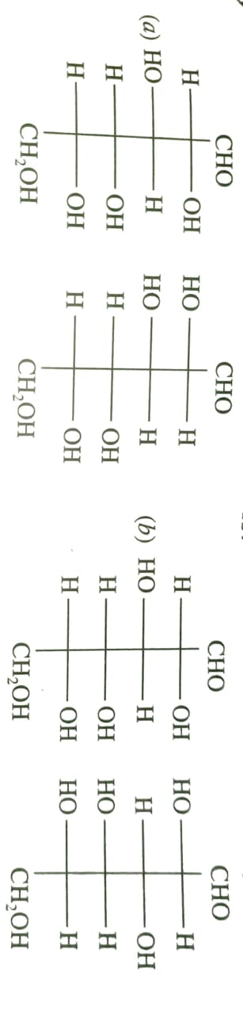

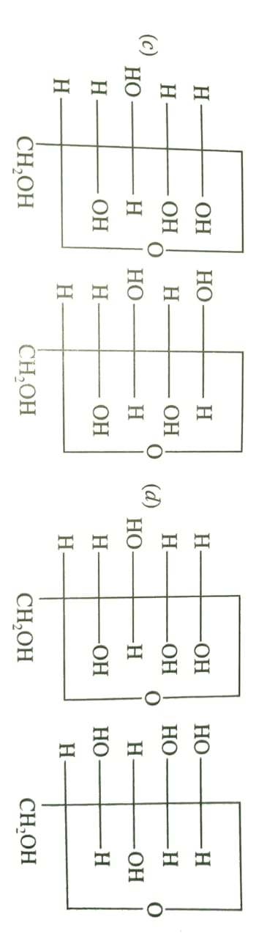

1. Carbohydrates are classified on the basis of their behaviour on hydrolysis and also as reducing or non-reducing sugar. Sucrose is a ___________.

|  |  |  |  |
| --- | --- | --- | --- |
| a) monosaccharides | b) disaccharides | c) reducing sugar | d) non-reducing sugar |

1. Which of the following statement is not true about glucose?

|  |  |
| --- | --- |
| a) It is an aldohexose | b) On heating with HI it form n-hexane |
| c) It is present in furanose form | d) It does not give 2,4-DNP test |

1. Which of the following reactions of glucose can be explained only by its cyclic structure?
2. Glucose forms pentaacetate.
3. Glucose reacts with hydroxylamine to form an oxime.
4. Pentaacetate of glucose does not react with hydroxylamine.
5. Glucose is oxidized by nitric acid to gluconic acid.

**Section – B [ 2 X 5 = 10 ]**

1. What are the hydrolysis product of (i) Sucrose (ii) lactose?
2. Draw the structure of sucrose.
3. Explain why Fe is a transition metal but Na is not?
4. Calculate the magnetic moment of Ni 2+.
5. Draw Haworth projection of alpha and beta glucose.

**Section – C [ 3 X 5 = 15 ]**

1. The cell in which the following reaction occurs : 2 Fe3+  + 2 I –  2 Fe2+ + I2 has = 0.236 V at 298 K. Calculate the standard Gibbs energy and the equilibrium constant of the cell reaction.
2. What happens when D-glucose is treated with the following reagents? (i) HI (ii) Bromine water (iii) HNO3
3. Write the chemistry of recharging the lead storage battery.
4. Conductivity of 2.5 x 10 – 4 M methanoic acid is 5.25 x 10 – 5 S cm – 1. Calculate its molar conductivity and degree of dissociation? Given : (S cm2 mol – 1 ) : H+ = 349.5 , HCOO –  = 50.5
5. Define Molar conductivity and Cell constant

**Section – D [ 5 X 2 = 10 ]**

1. Using the standard electrode potentials given below, predict if the reaction between the following is feasible:

|  |  |  |
| --- | --- | --- |
| (i) Fe 3+ (aq) and I – (aq) | (ii) Ag + (aq) and Cu (s) | (iii) Fe 3+ (aq) and Br – (aq) |
| (iv) Ag (s) and Fe 3+ (aq) | (v) Br2 (aq) and Fe 2+ (aq) |  |

Given standard electrode potentials : $E_{{ Cu}^{2+}/Cu}^{o}$ = 0.34 V ; $E_{{ Ag}^{+}/Ag}^{o}$ = 0.80 V ; $E_{{ Fe}^{3+}/{Fe}^{2+}}^{o}$ = 0.77 V ;

$E_{{\frac{1}{2}I}_{2}/I^{-}}^{o}$ = 0.541 V ; s $E_{{\frac{1}{2}Br}_{2}/{Br}^{-}}^{o}$ = 1.09 V

Or

(i) Write the cell reaction and calculate the emf of the following cell at 298 K :

Sn (s) | Sn2+ (0.004 M) || H2+ (0.02 M) | H2 (g) (1 bar) | Pt (s) ; Given : $E_{{ Sn}^{2+}/Sn}^{o}$ =s – 0.14 V

(ii) Given reason :

* 1. On the basis of E0 value, O2 gas should be liberated at anode but it is Cl2 gas which is liberated in the electrolysis of aqueous NaCl.
  2. Conductivity of CH3COOH decreases on dilution.

1. Indicates the steps in the preparation of : (i) K2Cr2O7 from chromite ore (ii) KMnO4 from Pyrolusite ore